Help-Menu

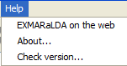

Help > EXMARaLDA on the web
On our EXMARaLDA homepage you can find an extensive assistance via the menu item Help, in particular a vast collection of examples for the practical work with the Partitur-Editor.

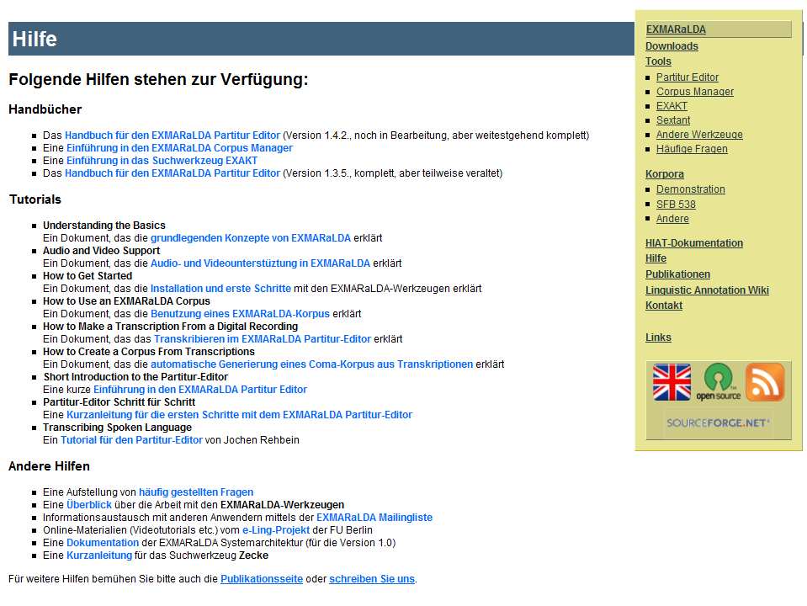

Help > About…
Displays an information dialog that lists the version of the EXMARaLDA Partitur-Editor you are currently using. Furthermore the "Java version“ and the "OS version“ are listed:

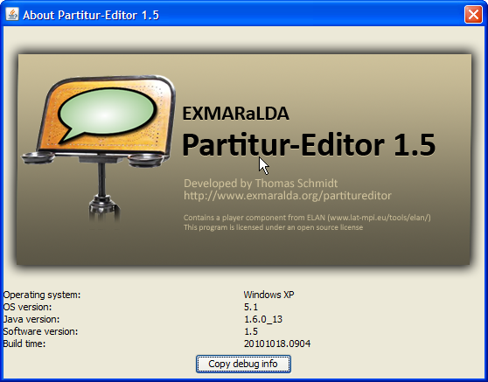

The button "Copy debug info…“ allows the copying of the log file content (the error messages etc.) into the clipboard. This is especially useful if you encounter errors in the software and would like to send the error messages to the developers.

Help > Check for update…
Shows you a web page that informs you whether the currently used version of the Partitur-Editor is the newest.

